SPRINT-4

|  |  |
| --- | --- |
| Team ID | PNT2022TMID38943 |
| Project Name | Smart waste management for metropolitan cities. |

1.Create the ibm cloud , then create python code connect to IBM Watson.

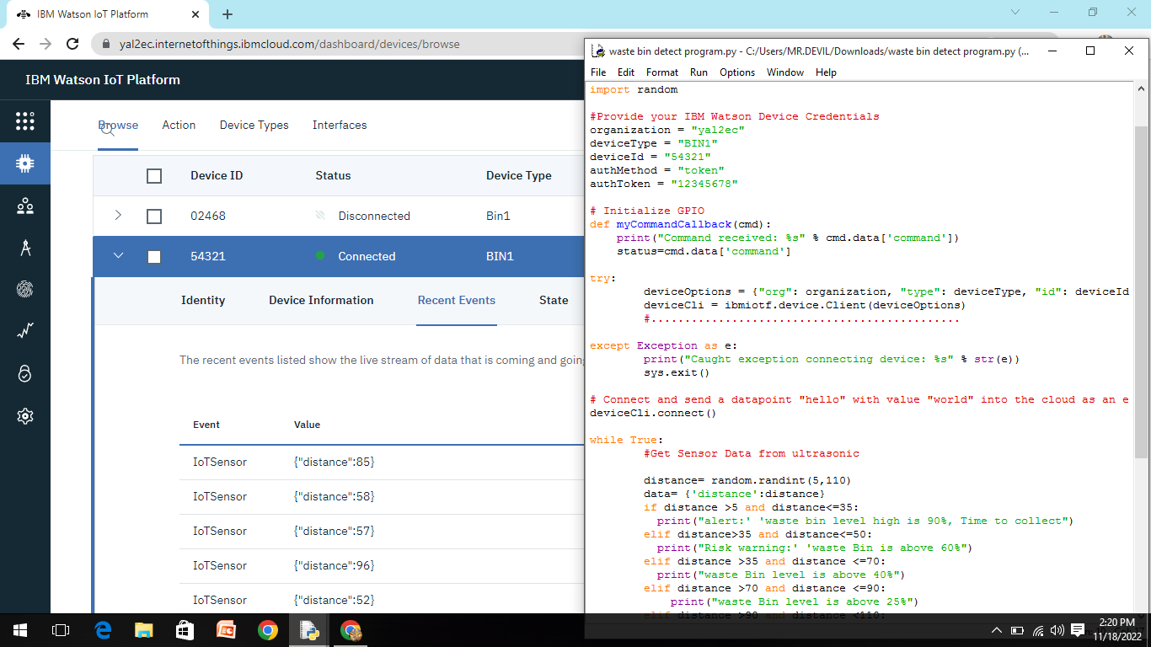

2.The IBM Watson is connected to NODE_RED.

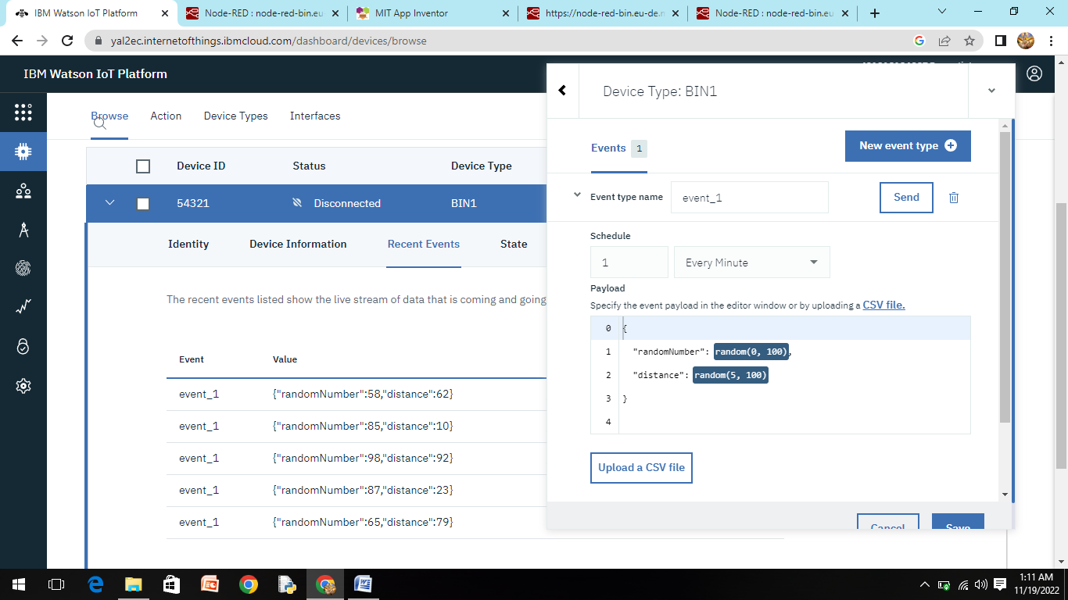

3.connect the proper connection in the NODE-RED

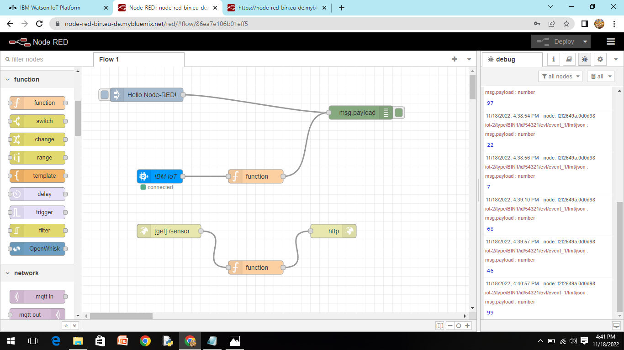

4. Create app in MIT app inverter and view the result in Mobile App.

